The Virginia Beach Bar Association is pleased to open registration for the annual Vegas CLE. This year’s CLE will be held at The Venetian Resort in the Palazzo Tower from Friday, September 5 to Monday, September 8. The Palazzo Tower provides a luxurious, suite-style layout in every room and this year, every room will include access to the Prestige Lounge. The Prestige Lounge offers breakfast each morning, snacks and water throughout the day, and heavy hors d’oeuvres and an open bar each night.

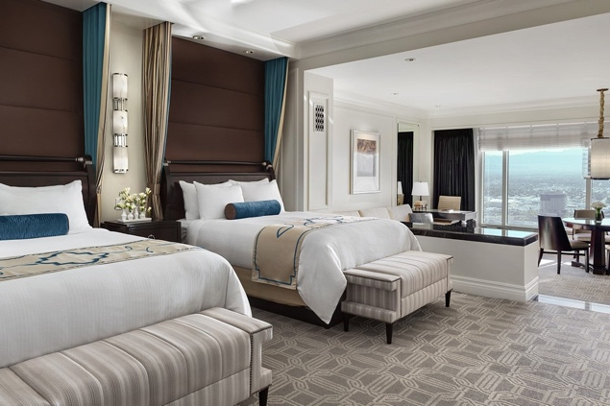 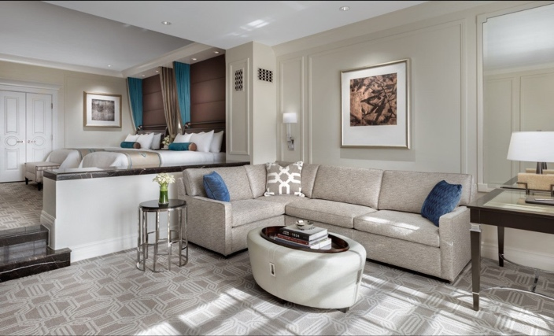

Included in the cost of the trip are the following:

* Accommodations for three nights at the Palazzo (Fri/Sat/Sun)
* Access to Palazzo Prestige Lounge featuring complimentary breakfast, happy hour and heavy hors d’oeuvres daily.
* Friday night cocktail reception
* 4 hours of CLE credit (2 Saturday morning, 2 Sunday morning)
* Sunday afternoon pool party (drinks and snacks included)

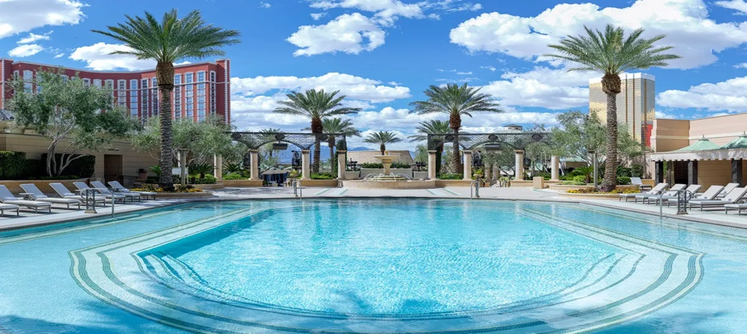

The trip does not include airfare. Additional days may be added, depending on hotel availability.

**Space IS LIMITED, so registration is first come, first served!

Rates:

|  |  |  |
| --- | --- | --- |
| King Room | 1 Attorney | $2,000 |
| King Room | 1 Attorney + Guest | $2,100 |
| King Room | 2 Attorneys | $2,200 |
| 2 Queen Room | 1 Attorney + Guest | $2,200 |
| 2 Queen Room | 2 Attorneys | $2,300 |

A deposit of 50% is due upon registration and payment in full is due by July 18. Viva Las Vegas!

Register for the trip on the VBBA website. Payment may be made by check or card.